SIMATS ENGINEERING

ASSESSMENT TOOL 3 – Assignment 2

COURSE NAME: STATISTICS WITH R PROGRAMMING COURSE CODE: ITA04

COURSE OUTCOME COVERED

CO3: Construct and manipulate data frames using reshaping, merging, and file I/O

operations in R to prepare structured datasets for analysis. (BL3, BL5)

Assessment Tool Weightage: 20%

QUESTIONS: 5 Total Marks: 100

Assignment 2

Code of Conduct:

I Narmadha M / 192320088 certify that this submission is my original work and that I have adhered to the guidelines specified for this assessment. I understand that any violation of academic integrity rules will result in disciplinary action.

Signature of the student:
Narmadha
Assignment 2:

Generate 5 Questions for your Capstone Project module

Apply the formulae and use the relevant graph to visualize it

Upload the file in Github link

Save the 5 Questions and Gihub link in the Excell sheet

Module 2 – Sequence Validation and Cleaning

Question 1
How can we analyze the distribution of protein sequence lengths using a histogram?

2. Aim
To represent the distribution of protein sequence lengths using a histogram in RStudio.

3. Purpose
To understand how protein sequence lengths are distributed across different length ranges.

4. Formula
fk=Number of sequences in length interval kfk​=Number of sequences in length interval k
Where fkfk​ represents the frequency of sequences within each length range.

5. R Code

sequence_lengths <- c(85, 92, 96, 100, 104,
108, 112, 118, 125, 132)

hist(sequence_lengths,
breaks = 5,
col = "skyblue",
main = "Distribution of Protein Sequence Lengths",
xlab = "Length (amino acids)",
ylab = "Number of Sequences")

6. Explanation of Results
- X-axis: Shows protein sequence length ranges in amino acids.
- Y-axis: Shows the number of sequences within each range.
- Bars: Represent the frequency of sequence lengths in each interval.
- Observation: The sample sequence lengths range from 85 to 132 amino acids.
The histogram helps show which length ranges contain more or fewer sequences.

7. Conclusion
The histogram provides a visual summary of protein sequence length distribution and helps identify common length ranges among the sample sequences.

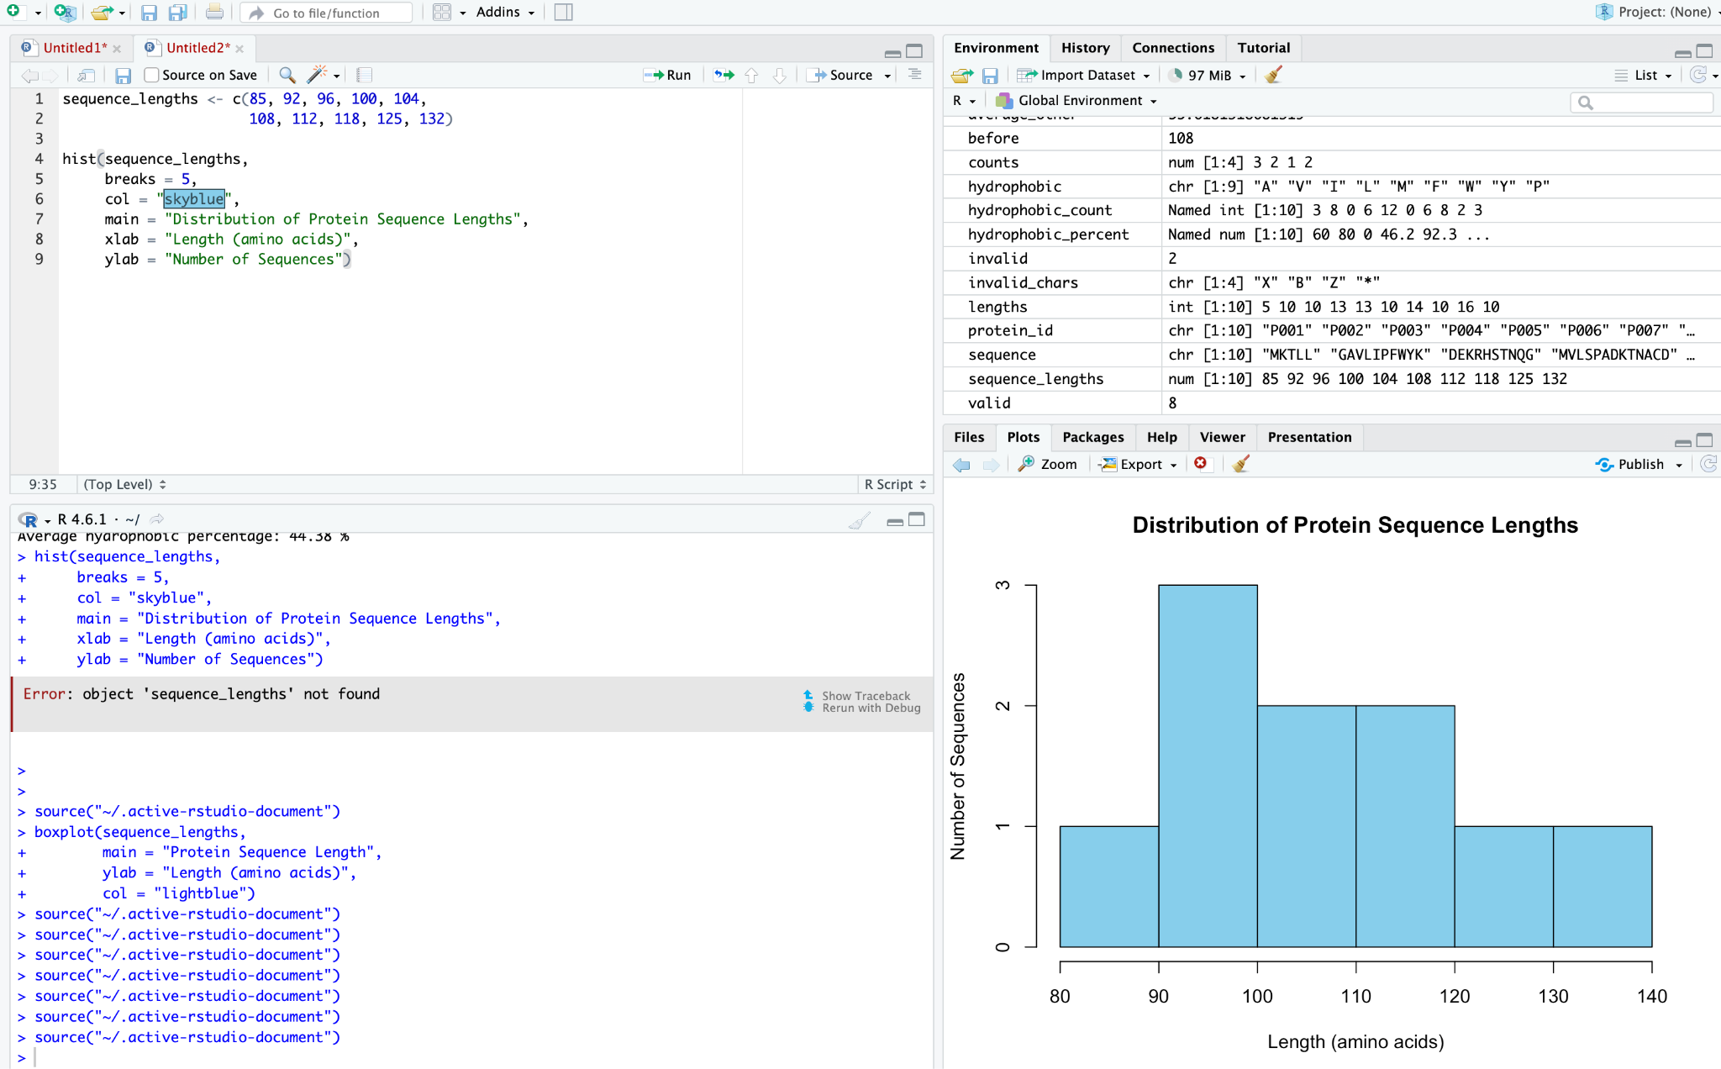

Question 2: How can we identify and count unsupported characters in a protein sequence using a bar chart?

Aim
To generate a bar chart showing the number of occurrences of unsupported characters in a protein sequence.

Purpose
To visualize the frequency of characters flagged during protein sequence validation and help identify potentially invalid or ambiguous characters.

Formula
N(c)=∑i=1LI(Si=c)N(c)=i=1∑L​I(Si​=c)
Where:
- N(c)N(c) = Number of occurrences of character cc
- SiSi​ = Character at position ii in the sequence
- LL = Total number of characters
- I(Si=c)=1I(Si​=c)=1 if the character matches, otherwise 00

R Code

invalid_chars <- c("X", "B", "Z", "*")
counts <- c(3, 2, 1, 2)

barplot(counts,
names.arg = invalid_chars,
col = "orange",
main = "Unsupported Characters",
xlab = "Character",
ylab = "Occurrences")

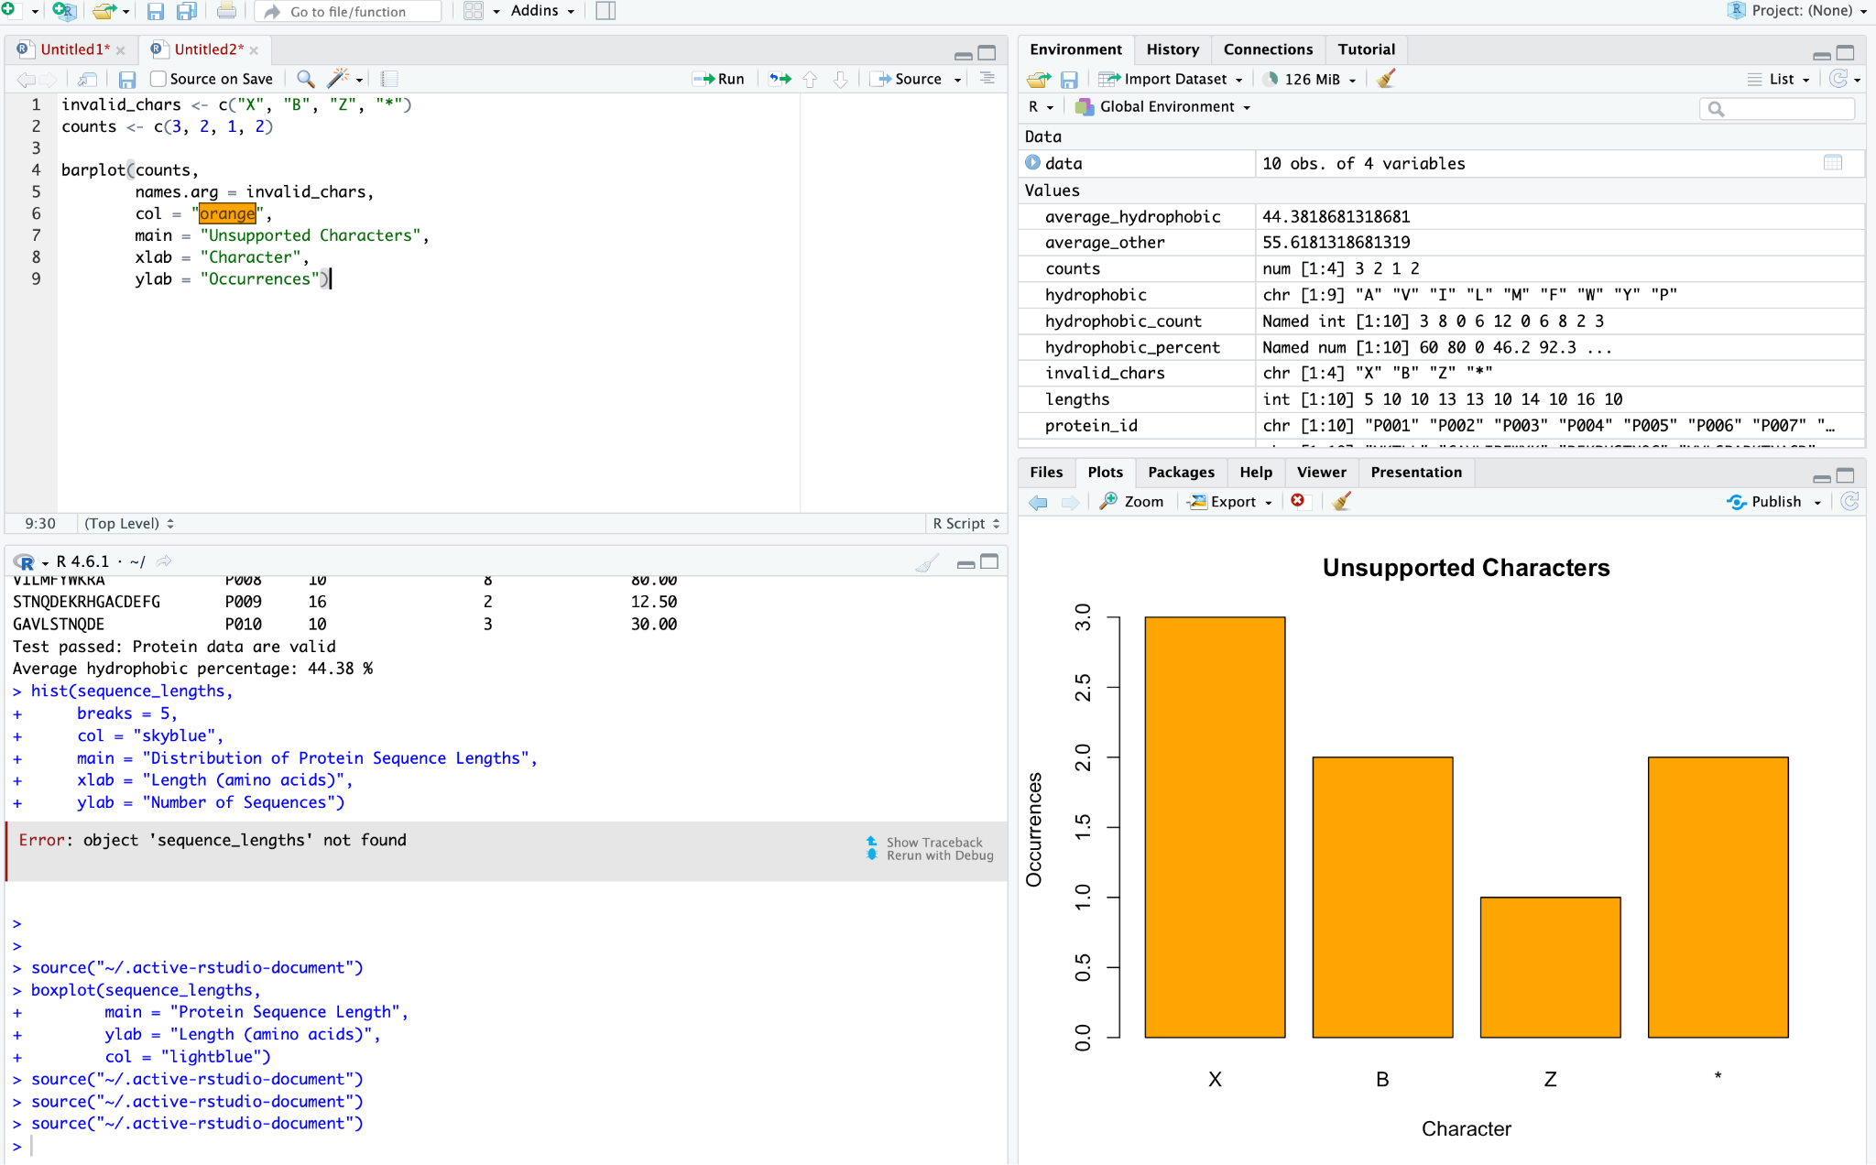

Explanation of Results
The bar chart displays the occurrence count of each character in the sample data.
Character | Count | Interpretation
X | 3 | Appears most frequently
B | 2 | Appears twice
Z | 1 | Appears once
* | 2 | Appears twice
- X: Has the highest count, with 3 occurrences.
- B and *: Each occurs 2 times.
- Z: Has the lowest count, with 1 occurrence.
Conclusion: The chart shows which characters occur most frequently and can help identify sequences that need further validation.

Question 3: How does cleaning affect the character count of a protein sequence before and after removing unnecessary spaces and line breaks?

1. Aim
To compare the protein sequence character count before and after cleaning using a line plot in RStudio.

2. Purpose
To show how cleaning removes unnecessary spaces and line breaks from a protein sequence, reducing its character count and preparing it for further analysis.

3. Formula
Lafter=Lbefore−WLafter​=Lbefore​−W
Where:
- LbeforeLbefore​ = Character count before cleaning
- LafterLafter​ = Character count after cleaning
- WW = Number of removable whitespace characters
For the given example:
W=108−100=8W=108−100=8
Therefore, 8 characters were removed during cleaning.

4. R Code

before <- 108
after <- 100

plot(c(1, 2), c(before, after),
type = "o",
xaxt = "n",
xlab = "Cleaning Stage",
ylab = "Character Count",
main = "Sequence Length Before and After Cleaning",
col = "blue",
pch = 16)

axis(1, at = c(1, 2),
labels = c("Before Cleaning", "After Cleaning"))

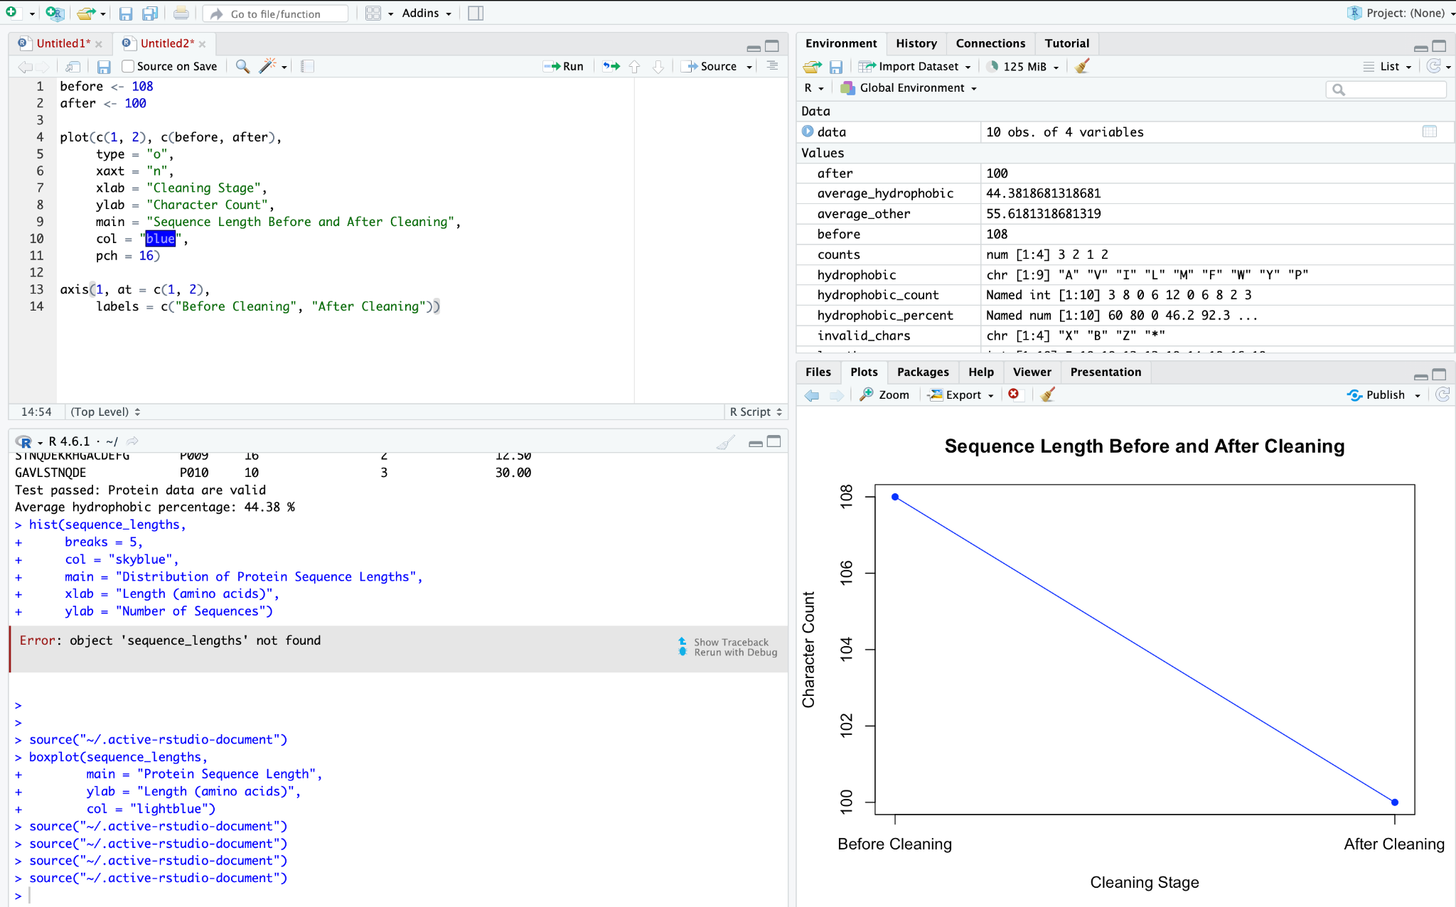

5. Explanation of Results
- Before cleaning: The sequence contains 108 characters.
- After cleaning: The sequence contains 100 characters.
- Difference: The character count decreases by 8.
- Blue line: Connects the two values and shows the decrease after cleaning.
The plot demonstrates the effect of cleaning on the sequence character count.

6. Conclusion
The line plot shows that the character count decreased from 108 to 100 after cleaning. This indicates that 8 characters were removed, assuming they were unnecessary spaces or line breaks. The cleaned sequence is then ready for further validation and analysis.

Question 4
How can we represent the percentage of valid and invalid protein sequences using a pie chart?

2. Aim
To represent the proportion of valid and invalid protein sequences using a pie chart in RStudio.

3. Purpose
To visualize the validation results and understand how many sequences pass or fail the validation process.

4. Formula
Percentage=CountTotal sequences×100Percentage=Total sequencesCount​×100
Total sequences:
N=8+2=10N=8+2=10
- Valid percentage = 810×100=80%108​×100=80%
- Invalid percentage = 210×100=20%102​×100=20%

5. R Code

valid <- 8
invalid <- 2

pie(c(valid, invalid),
labels = c("Valid", "Invalid"),
col = c("lightgreen", "tomato"),
main = "Sequence Validation Results")

6. Explanation of Results
- Valid sequences: 8 sequences, representing 80% of the total.
- Invalid sequences: 2 sequences, representing 20% of the total.
- Light green slice: Represents valid sequences.
- Tomato-red slice: Represents invalid sequences.
The pie chart shows that most of the sample sequences are valid.

7. Conclusion
The pie chart indicates that 80% of the sample sequences are valid and 20% are invalid. This visualization helps assess the input sequence validation results.

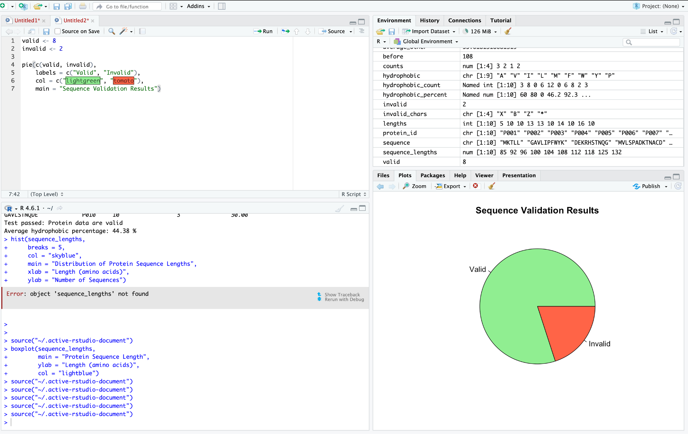

Question 5
How can we analyze the distribution of protein sequence lengths using a box plot?

2. Aim
To represent the distribution of protein sequence lengths using a box plot in RStudio.

3. Purpose
To understand the spread, median, and variability of protein sequence lengths across multiple sample sequences.

4. Formula
Sequence length:
L=Number of amino acids in a sequenceL=Number of amino acids in a sequence
A box plot uses five key values:
- Minimum
- First quartile (Q1Q1​)
- Median (Q2Q2​)
- Third quartile (Q3Q3​)
- Maximum (within the whisker limits)

5. R Code

sequence_lengths <- c(85, 92, 96, 100, 104,
108, 112, 118, 125, 132)

boxplot(sequence_lengths,
main = "Protein Sequence Length",
ylab = "Length (amino acids)",
col = "lightblue")

6. Explanation of Results
- Median: Shows the middle value of the sequence lengths.
- Box: Represents the middle 50% of the values, from Q1Q1​ to Q3Q3​.
- Whiskers: Show the spread of values within the box plot's limits.
- Outliers: Show unusually distant values, if present.
For this sample, the sequence lengths range from 85 to 132 amino acids, and the median is 106 amino acids.

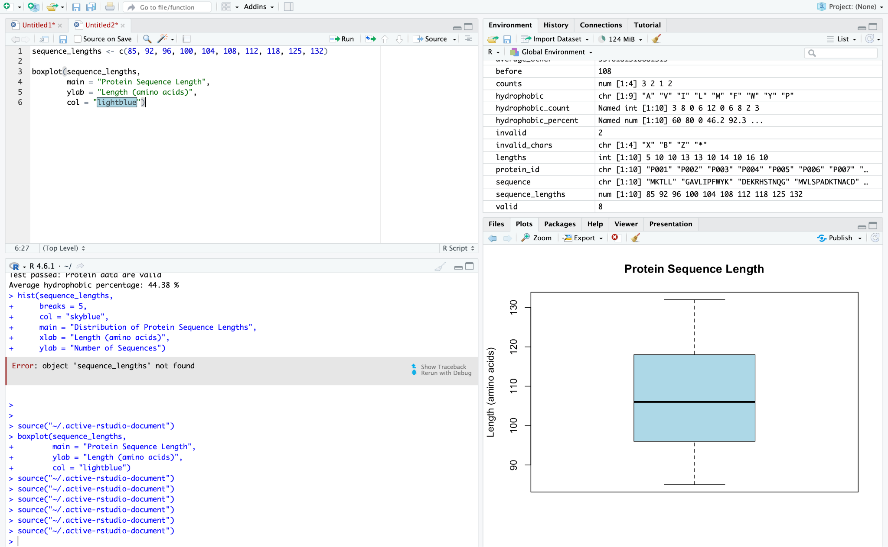

7. Conclusion
The box plot summarizes the distribution and variability of protein sequence lengths. It helps compare sequence sizes and identify potential outliers.

